OA.VA.99
Lost
0008548402027490697
UAT testlost
1121
01011980
371
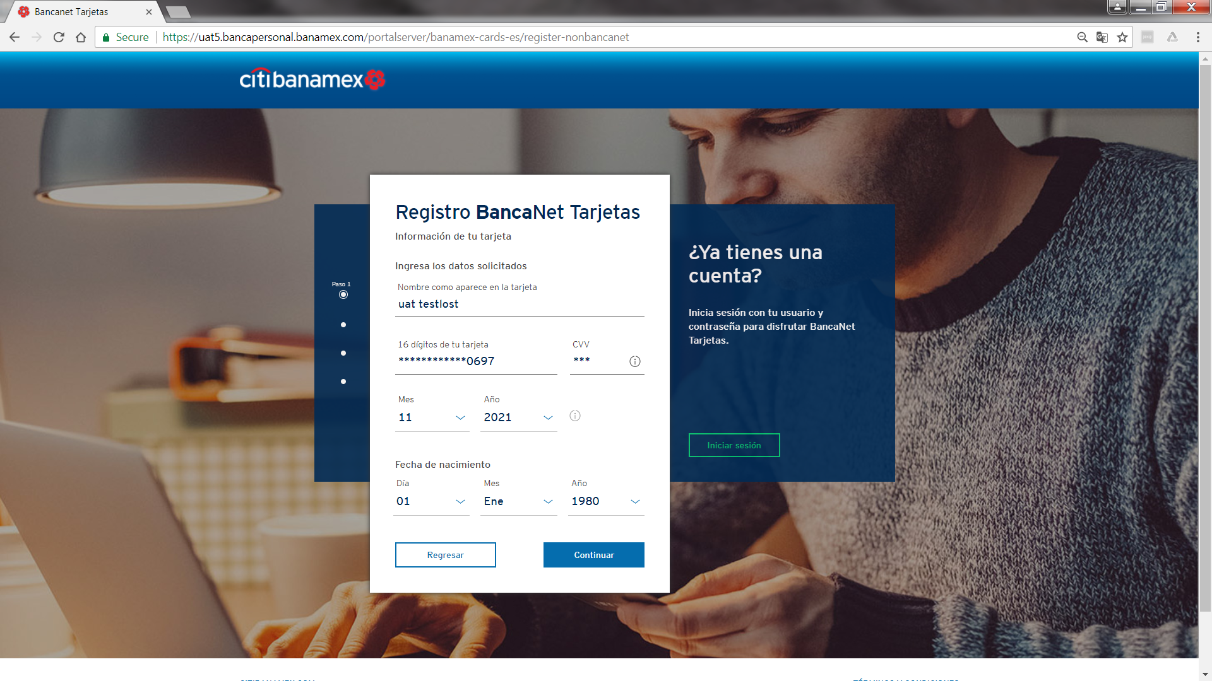
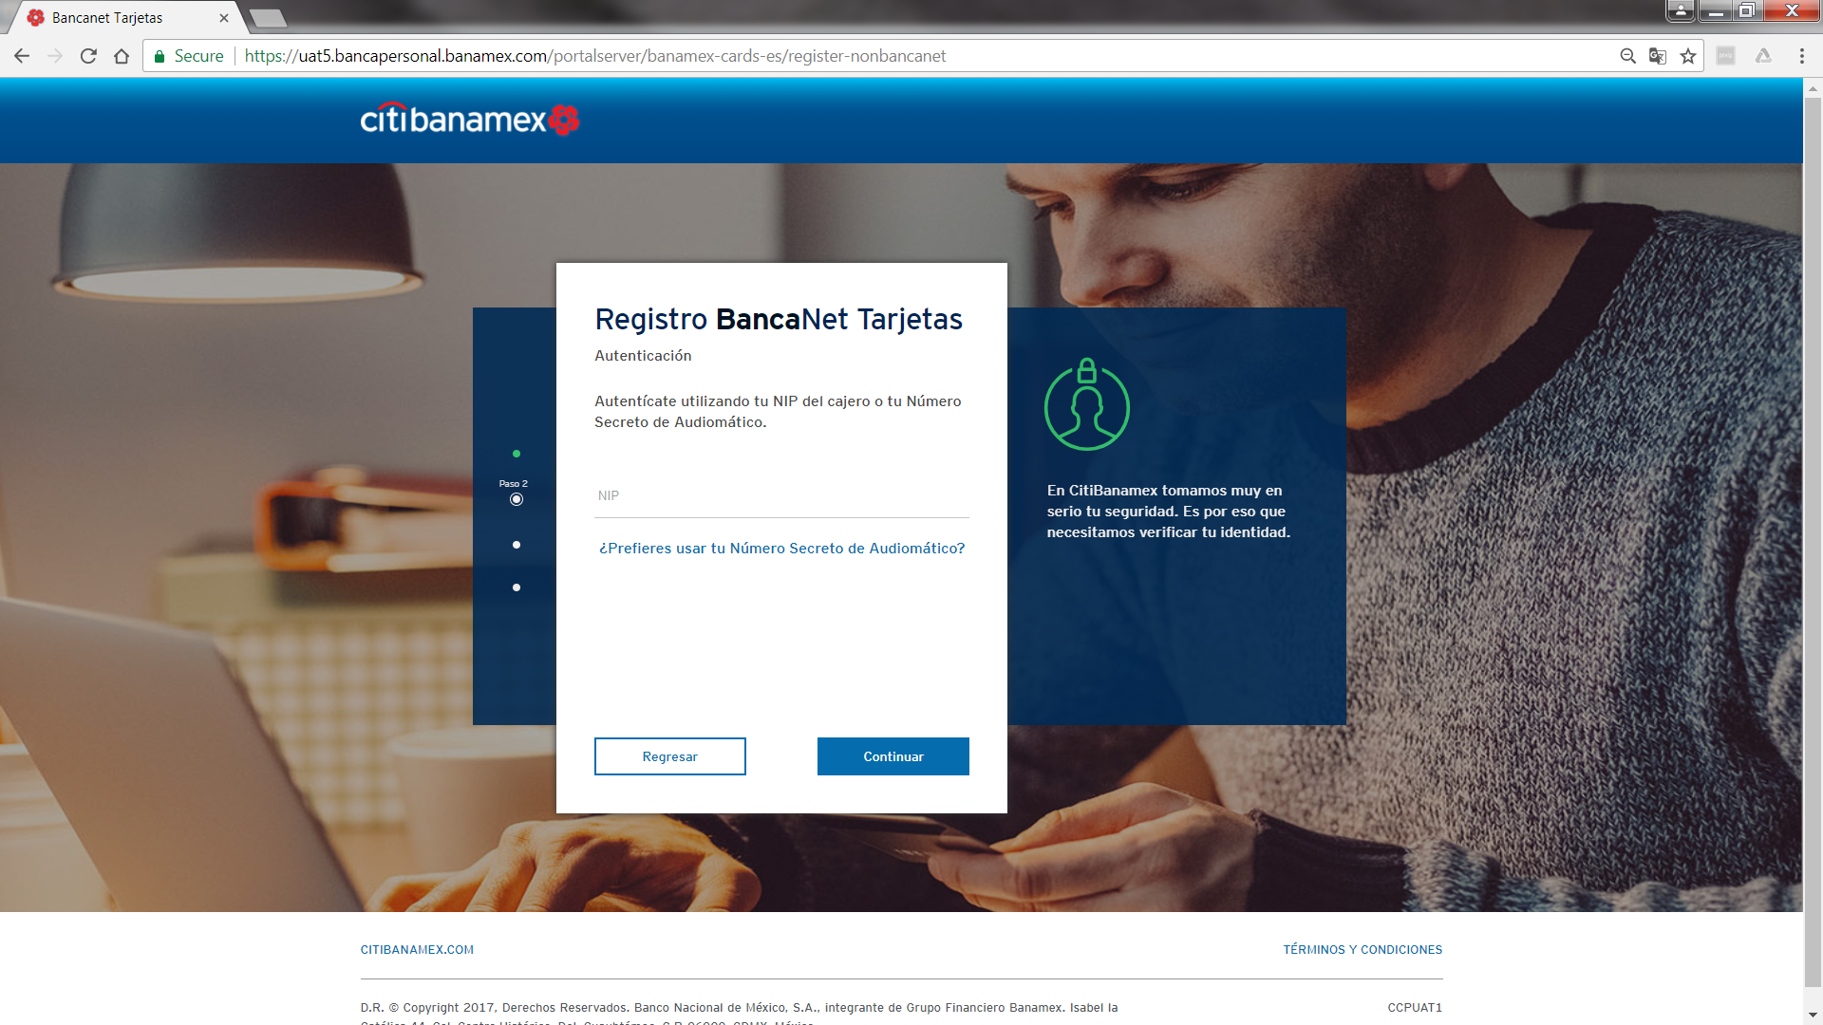

Stolen
0005456319101314591
UAT TESTSTOLEN
0621
01011980
685
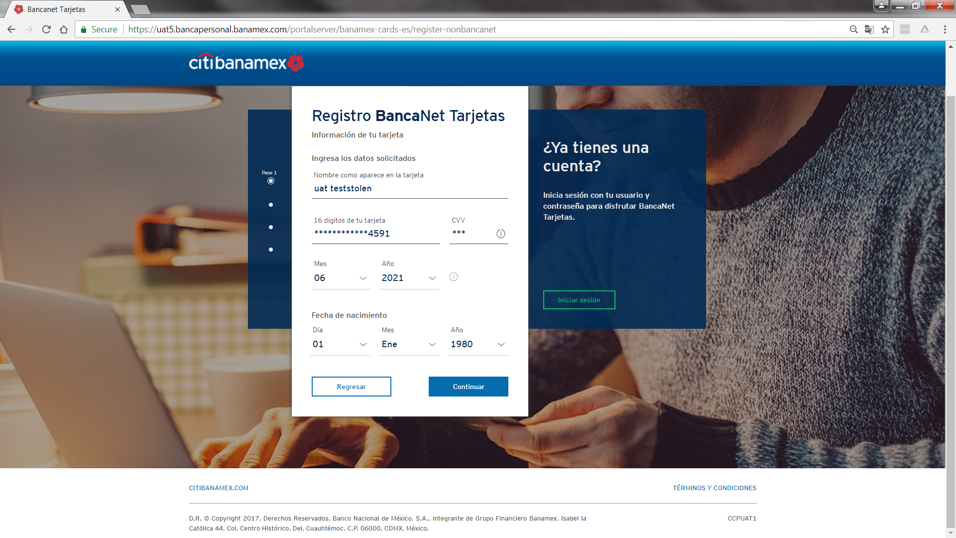

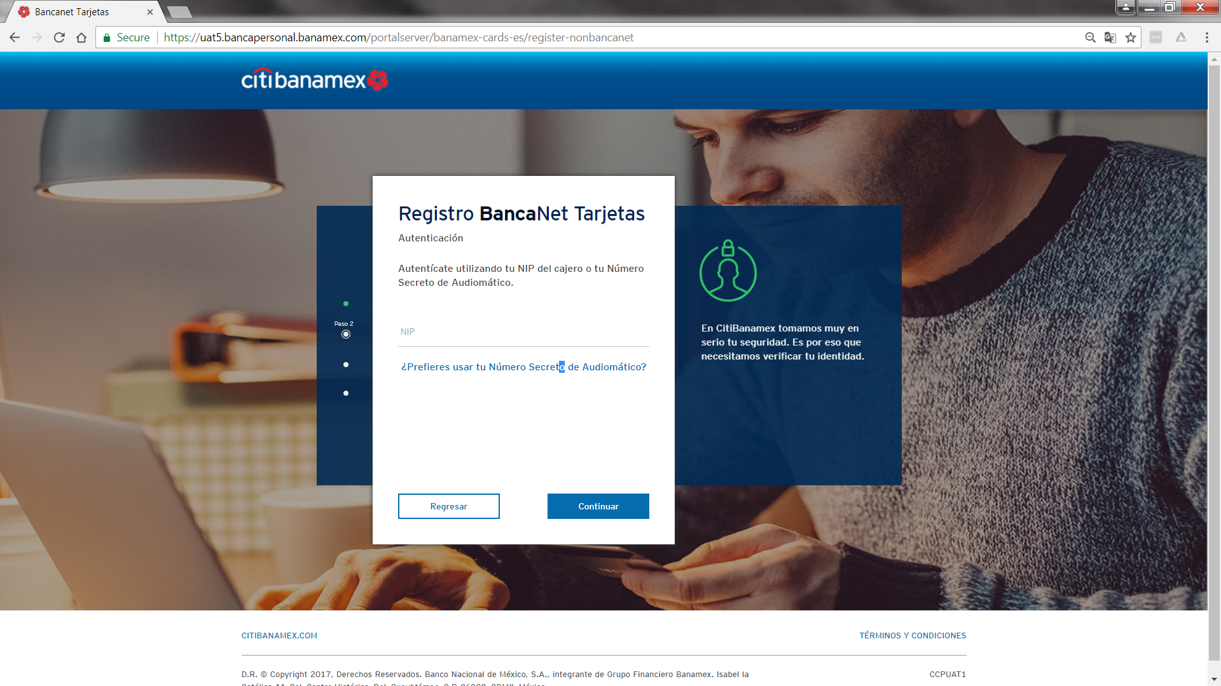
Fraud
0008548409200602485
0822
UAT TESTFR
01011980
976

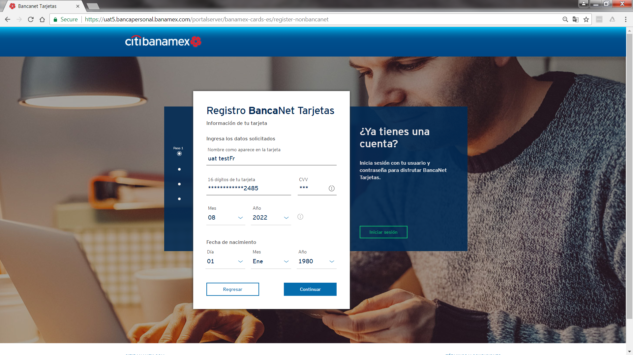

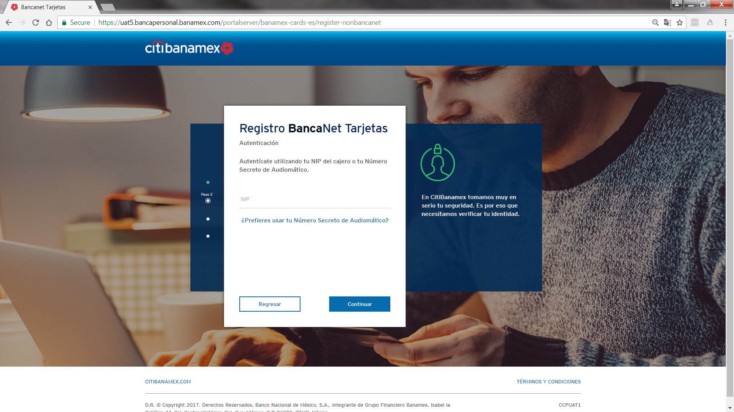

Additional data

Fraud
0004053060000531691 0000000000083993880
4/30/2018
ZXXY ZXZYXYXYYZYZYYY
325-CVV
01011980

Lost
0004053060000537391 0000000000018407801

4/30/2018 XZYZZZYZYXXZZXYYXXXYZ
505 -CVV
01011980

stolen
0004053069032630371 0000000000003917357
6/30/2018 XXXYZZYYYYXXZZZZYY

670-CVV
01011980

